Five stars for a reason — Limited-time deals for Sennheiser EW-D wireless systems
Stand a chance to win a pair of limited 80th anniversary edition Ruby Red HD 25

Sydney Australia, 6 June 2025 — Sennheiser’s Evolution Wireless Digital EW-D microphone systems have become a staple for bands and performers who value audio quality and UHF reliability. With setup simplicity via the Smart Assist app, operating an Evolution Wireless Digital system is a breeze. For those who have not yet made the switch to digital wireless, the month of June presents an ideal opportunity: Participating Sennheiser dealers will offer discounts on Sennheiser’s EW-D wireless microphone and instrument systems between 1 June 2025 and 30 June 2025. As a bonus, and to kick off its 80th anniversary in style, Sennheiser is releasing 80 pairs of special 80th anniversary edition Ruby Red HD 25 headphones. All that participants have to do for a chance to win is share their experience with Sennheiser’s professional wireless products here, no purchase necessary.

Throughout June, special offers are in place for EW-D wireless systems at participating dealers

“Evolution Wireless Digital EW-D has become the go-to series for those who demand professional sound and performance without the complexity,” explains Jimmy R. Landry, Category Market Manager MI at Sennheiser. “To celebrate that success and Sennheiser’s 80th anniversary, we are excited to release 80 pairs of limited-edition HD 25 headphones. For a chance to win, all you have to do is share your experience with Sennheiser professional wireless products, no purchase necessary. It’s our way of saying thank you and celebrating eight decades of innovation in sound.”

The limited 80th anniversary edition Ruby Red HD 25 | 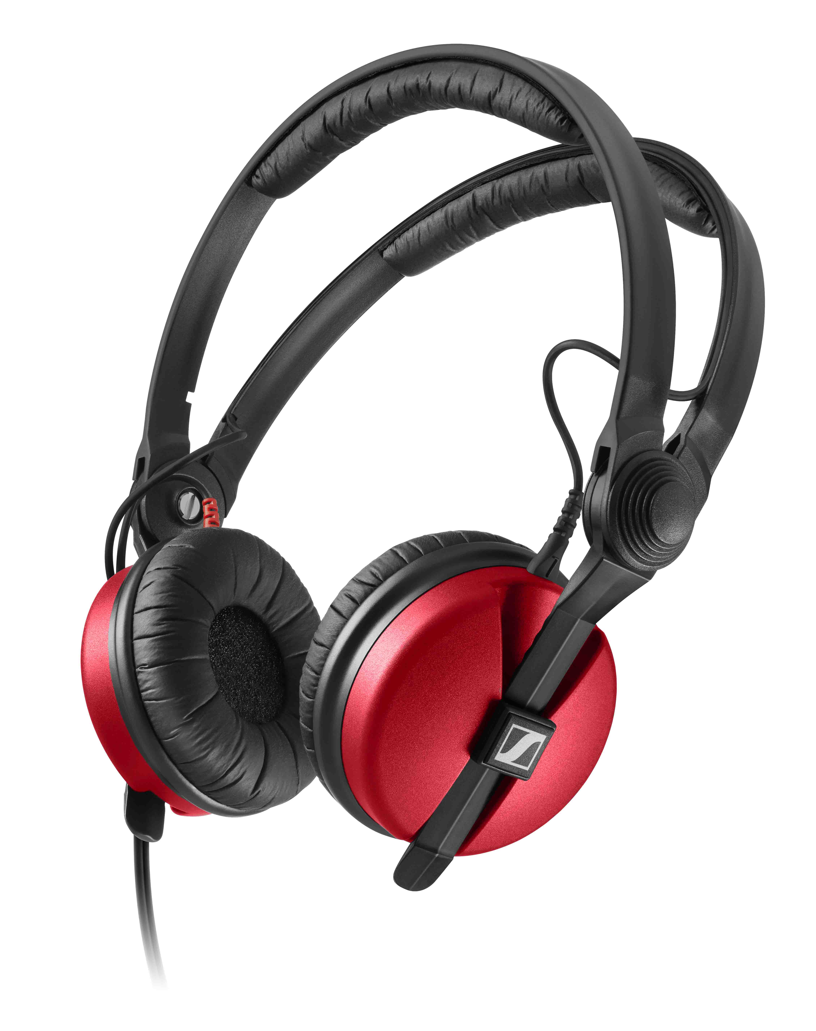
Five stars for a reason
The Evolution Wireless Digital EW-D series was designed to make wireless as easy as using an app — and has garnered 5-star reviews about its pristine audio quality, rock-solid reliability, and the worry-free Smart Assist app, which takes over the tedious job of setting up the wireless for a gig, and helps in monitoring and troubleshooting.

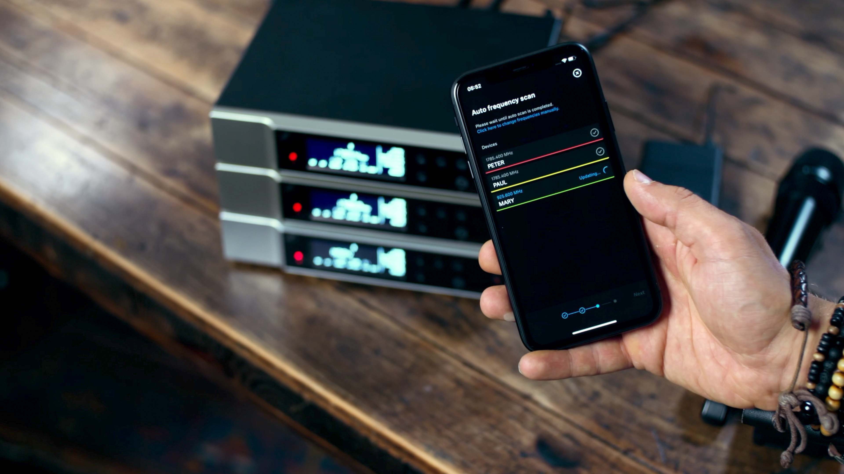 | The Smart Assist app makes setting up a wireless system a breeze

Just like evolution wireless G4, Evolution Wireless Digital features a professional UHF connection between tour-proof transmitters and receivers, but it takes users from the analogue to the digital world. Digital wireless offers some sonic advantages over analogue, there is no RF noise floor, and the audio is crisp and clear. The latency of EW-D systems is at just 1.9 ms, which makes the sound feel natural and immediate, and thanks to the ultra-wide dynamic range of 134 dB on the transmitter, the EW-D wireless mic will handle very quiet and extremely loud sources effortlessly.

A chance to win 80th anniversary edition Ruby Red HD 25 headphones
“At Sennheiser, we’re always happy about the feedback we receive from our professional users,” says Landry, ”And sharing your experiences with Sennheiser wireless now gives participants a chance to own a piece of Sennheiser history, a special edition Ruby Red HD 25.”

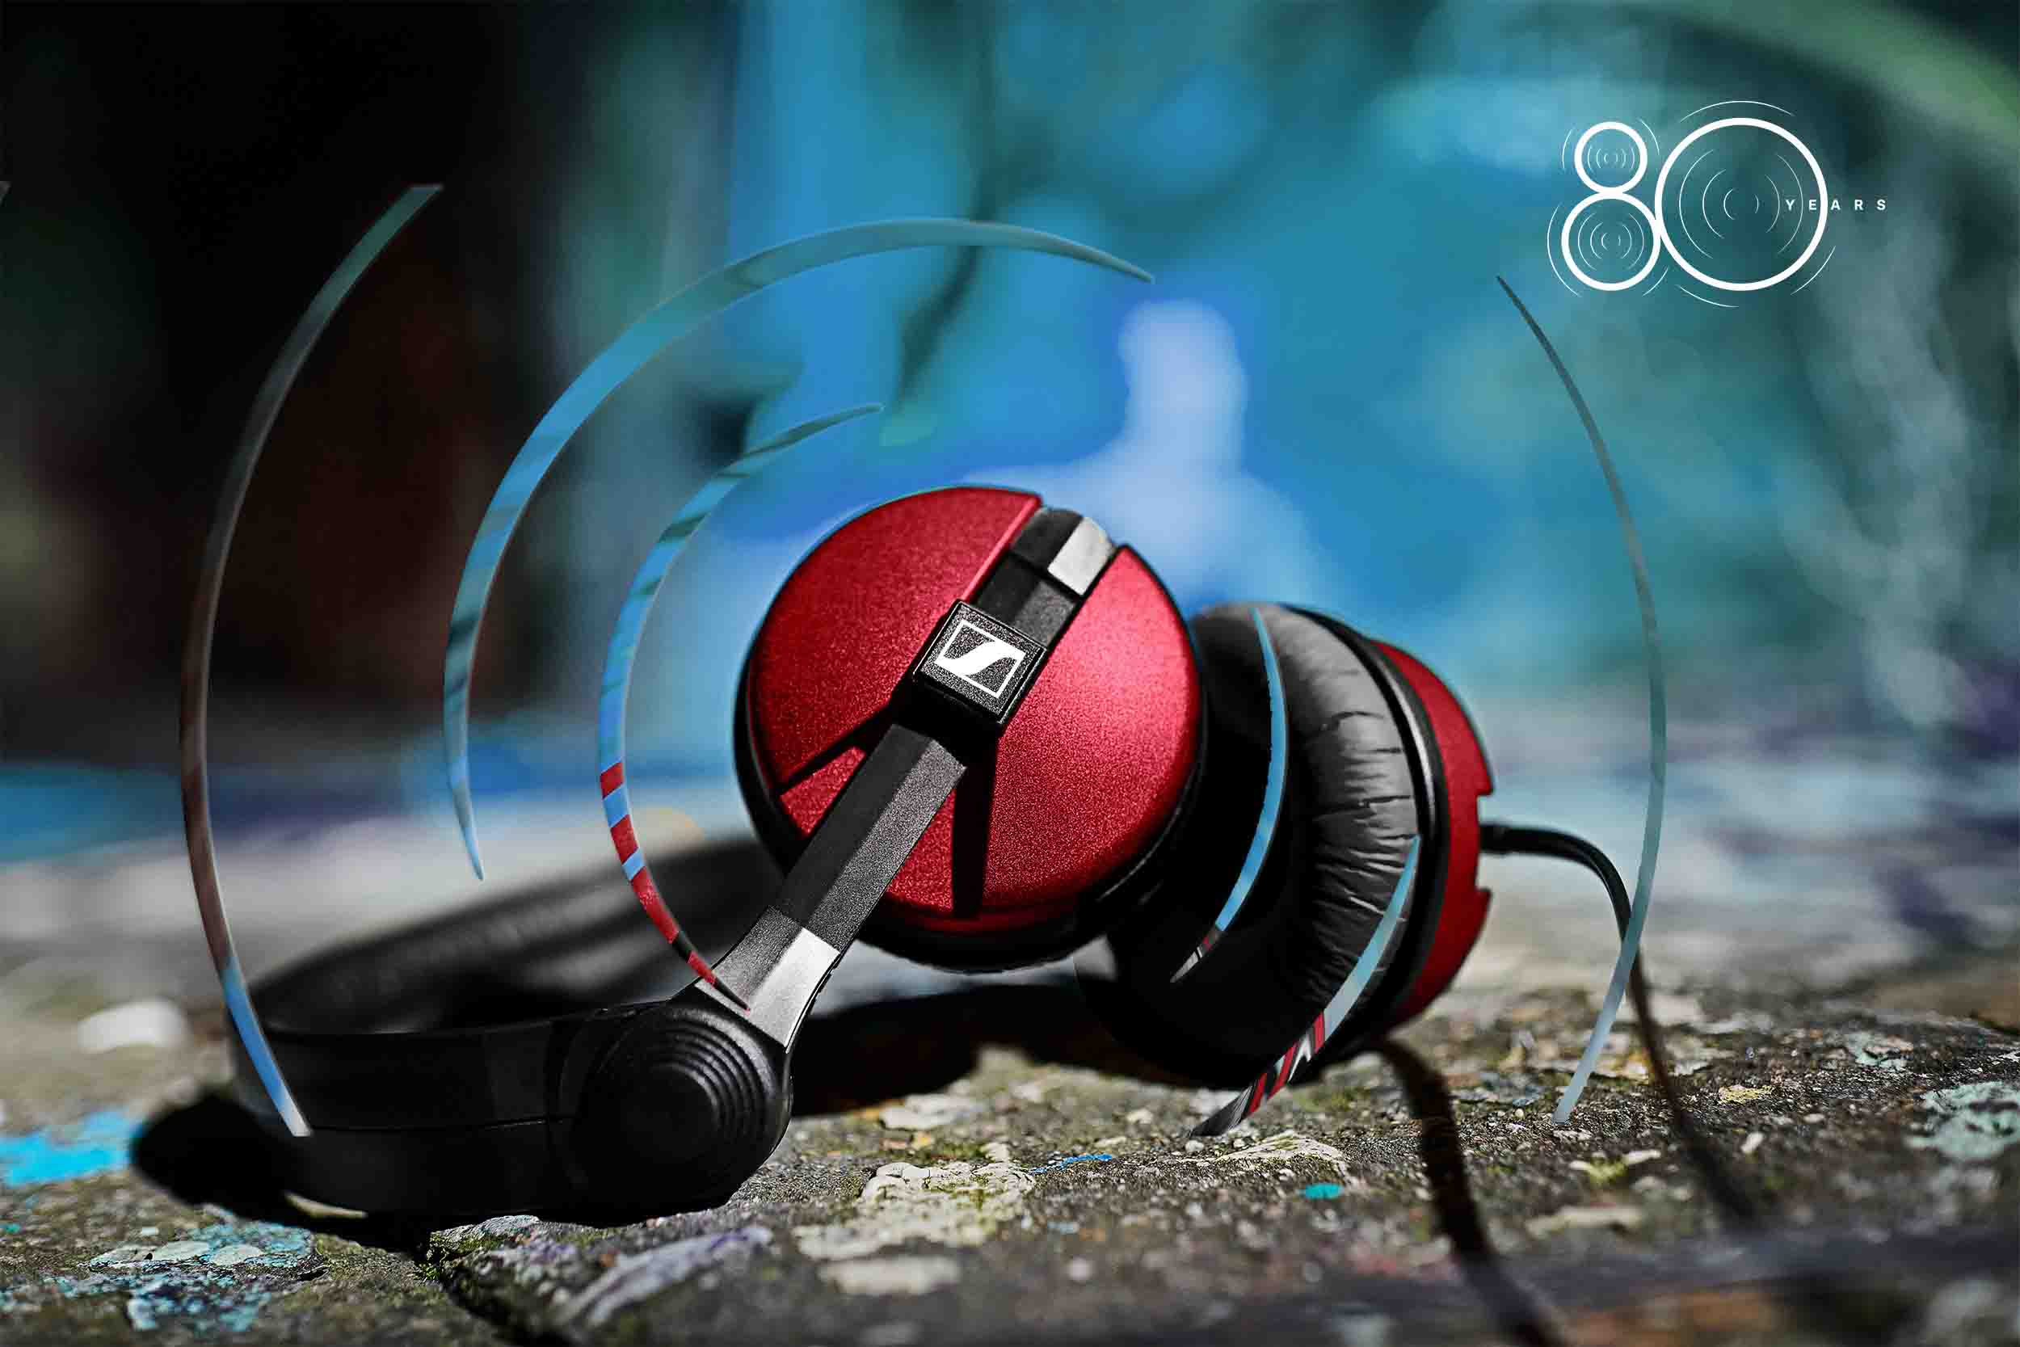

To stand a chance to win one of 80 pairs of limited 80th anniversary edition Ruby Red HD 25s, participants are asked to visit https://www.sennheiser.com/rubyred for the submission form and the full contest terms and conditions. Please note that no purchase is required. A Sennheiser wireless experience can be shared between 6 June 2025, 10 a.m. CEST and 31 August 2025, 11:59 p.m. CEST. A jury selected by Sennheiser will select the winning comments based on the creativity and passion for the product. Best of luck!

(Ends)

The high-resolution images accompanying this media release can be downloaded here.

About the Sennheiser brand
We live and breathe audio. We are driven by the passion to create audio solutions that make a difference. Building the future of audio and bringing remarkable sound experiences to our customers – this is what the Sennheiser brand has represented for more than 75 years. While professional audio solutions such as microphones, meeting solutions, streaming technologies and monitoring systems are part of the business of Sennheiser electronic SE & Co. KG, the business with consumer devices such as headphones, soundbars and speech-enhanced hearables is operated by Sonova Holding AG under the license of Sennheiser.

www.sennheiser.com
www.sennheiser-hearing.com

Communications Manager – Americas, ANZ, Sennheiser
Daniella Kohan
Daniella.Kohan@sennheiser.com
+1 860 598 7420

